CAMPEP Graduate and Residency Education Program
Annual Program Review Instructions
- On every year that your program accreditation is still active, you will receive an automated email (subject “Your CAMPEP Annual Program Review is Due”) 60 days prior to each year your program is accredited.
- The first email will contain notices (i.e. *****FIRST NOTICE*****, *****SECOND NOTICE*****, *****THIRD NOTICE*****, and *****FINAL NOTICE*****). These notices will be sent every two weeks (beginning at the 60 day mark) until you have uploaded your program review into CAMPEP. Once your review has been uploaded for the year, you will no longer receive the automated email.
- On the left menu, click on the link titled “Annual Program Review”.
- If you have no reviews that are due, the following screen will look like this...
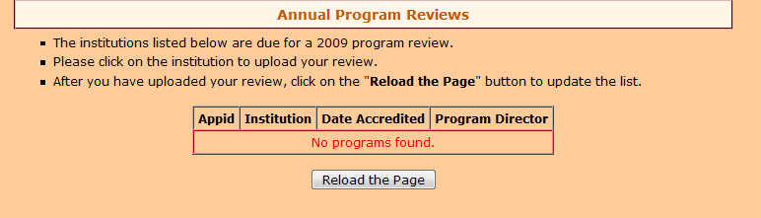

- If you have a review that is due, the following screen will look like this…
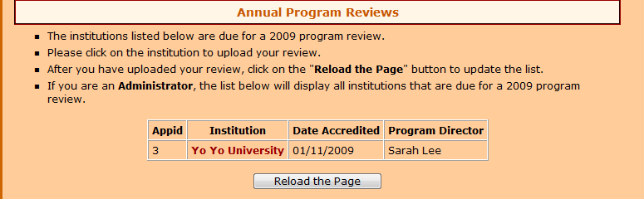

- To upload your annual program review, click on the institution link and the following screen will appear.
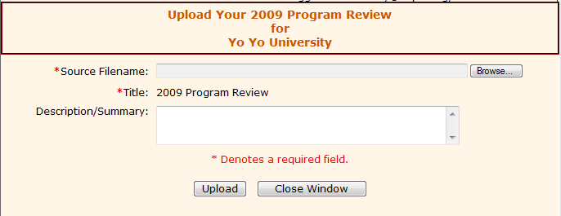

- Click on the “Browse” button to locate the file on your computer.
- Then enter (if any) a description/summary.
- Click on the “Upload” button and the following screen will appear.
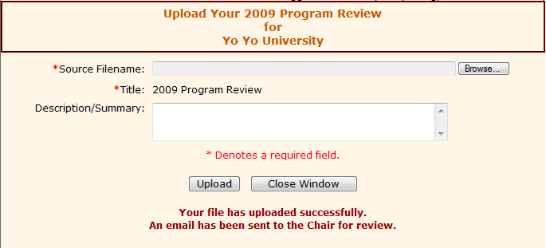

- An email will be automatically sent to the Chair for review.

- When finished, click on the “Close Window” button to return to the previous window.

- Now since you have uploaded your review, just click on the “Reload the Page” button and the following screen will appear.

- And that’s all there is to it. If you should have any questions, please contact Jackie Ogburn at campep_admin@campep.org.

